Jonathan Masukawa (33128396) Yan Zhao (31018809) Group #32

The average burst size greatly increases turnaround time and waiting time, but not in a directly linear way. From an average burst of 20 to an average burst of 40, non-preemptive waiting time increased by a factor of 40, while turnaround time increased by a factor of 26. The preemptive waiting time increased by a factor of 47, while the preemptive turnaround time increased by a factor of 29. From the average 40 burst to the average 60 burst results, the wait and turn time increased by roughly 2.5 times for non-preemptive, and about 3 times for the wait and turn time of the preemptive version. From an average burst of 60 to an average burst of 80, both preemptive and non-preemptive increased by just under a factor of two. We can see then that wait and turnaround time increase, but at a decreasing rate as burst size increases.

This is intuitive, since increasing burst time gives a higher probability of processes being starved out due to the CPU not being able to keep up quickly enough with the arrival of processes. This isn’t a problem initially with a burst size of 20 since the arrival of new processes was slower than the rate that processes were being completed. As the CPU gets backed up, processes will queue up, and the rate of degradation increases by factors, which our results show. At a certain point, the queue is so hopelessly behind that additional processes to the queue decrease performance more linearly, since one more process is small compared to the relative size of the queue. We can say then, that when a process is being overwhelmed initially, wait time and turnaround time increase exponentially, but at a decreasing rate. At a certain point in time, the rate at which the wait and turnaround time increase will be linear, and then subsequently, sub-linear.

The preemptive version of the process provides a slightly better turnaround time, but for the most part, SJF non-preemptive and SJF preemptive for our data give almost the same results once the processor gets overwhelmed. For lower bursts, SJF preemptive will give lower turnaround time because the more processes on average will be completed sooner.

Jonathan Masukawa (33128396) Yan Zhao (31018809) Group #32

|  |  |  |  |  |  |  |  |  |
| --- | --- | --- | --- | --- | --- | --- | --- | --- |
| Processes - 250, Avg Burst - 20, Avg arrival - 20, Avg Priority - 4 | | | |  | Processes - 250, Avg Burst - 40, Avg arrival - 20, Avg Priority - 4 | | | |
| **SJF (non-preemptive) Burst 20** | | | |  | **SJF (non-preemptive) Burst 40** | | | |
|  | **Wait** | **Response** | **Turnaround** |  |  | **Wait** | **Response** | **Turnaround** |
| **Min** | 0 | 0 | 1 |  | **Min** | 0 | 0 | 5 |
| **Mean** | 32.97 | 32.97 | 52.22 |  | **Mean** | 1308.94 | 1308.94 | 1346.33 |
| **Max** | 734 | 734 | 794 |  | **Max** | 8598 | 8598 | 8680 |
| **StdDev** | 80.2 | 80.2 | 87.5 |  | **StdDev** | 2536.19 | 2536.19 | 2560.87 |
|  |  |  |  |  |  |  |  |  |
| Processes - 250, Avg Burst - 60, Avg arrival - 20, Avg Priority - 4 | | | |  | Processes - 250, Avg Burst - 80, Avg arrival - 20, Avg Priority - 4 | | | |
| **SJF (non-preemptive) Burst 60** | | | |  | **SJF (non-preemptive) Burst 80** | | | |
|  | **Wait** | **Response** | **Turnaround** |  |  | **Wait** | **Response** | **Turnaround** |
| **Min** | 0 | 0 | 12 |  | **Min** | 0 | 0 | 32 |
| **Mean** | 3545.43 | 3545.43 | 3602.65 |  | **Mean** | 5964.77 | 5964.77 | 6041.15 |
| **Max** | 13341 | 13341 | 13440 |  | **Max** | 18278 | 18278 | 18377 |
| **StdDev** | 3906.347 | 3906.347 | 3921.206 |  | **StdDev** | 5436.119 | 5436.119 | 5450.071 |
|  |  |  |  |  |  |  |  |  |
| Processes - 250, Avg Burst - 20, Avg arrival - 20, Avg Priority - 4 | | | |  | Processes - 250, Avg Burst - 40, Avg arrival - 20, Avg Priority - 4 | | | |
| **SJF (preemptive) Burst 20** | | | |  | **SJF (preemptive) Burst 40** | | | |
|  | **Wait** | **Response** | **Turnaround** |  |  | **Wait** | **Response** | **Turnaround** |
| **Min** | 0 | 0 | 1 |  | **Min** | 0 | 0 | 1 |
| **Mean** | 27.64 | 22.94 | 46.9 |  | **Mean** | 1307.62 | 1304.94 | 1345 |
| **Max** | 734 | 734 | 794 |  | **Max** | 8598 | 8598 | 8680 |
| **StdDev** | 85.01 | 80.96 | 93.66 |  | **StdDev** | 2537.72 | 2538.97 | 2562.41 |
|  |  |  |  |  |  |  |  |  |
| Processes - 250, Avg Burst - 60, Avg arrival - 20, Avg Priority - 4 | | | |  | Processes - 250, Avg Burst - 80, Avg arrival - 20, Avg Priority - 4 | | | |
| **SJF (preemptive) Burst 60** | | | |  | **SJF (preemptive) Burst 80** | | | |
|  | **Wait** | **Response** | **Turnaround** |  |  | **Wait** | **Response** | **Turnaround** |
| **Min** | 0 | 0 | 9 |  | **Min** | 0 | 0 | 32 |
| **Mean** | 3544.82 | 3541.5 | 3602.04 |  | **Mean** | 5964.53 | 5963.42 | 6040.91 |
| **Max** | 13341 | 13341 | 13440 |  | **Max** | 17921 | 17921 | 18020 |
| **StdDev** | 3907.119 | 3909.713 | 3921.987 |  | **StdDev** | 5435.424 | 5436.606 | 5449.382 |

Jonathan Masukawa (33128396) Yan Zhao (31018809) Group #32

|  |  |  |  |  |  |  |  |  |
| --- | --- | --- | --- | --- | --- | --- | --- | --- |
| **Performance Metric Ratio by Avg Burst (Avg burst = 20 as baseline case)** | | | | | | |  |  |
| **Avg Burst** | NP Avg Wait Ratio | NP Avg Resp Ratio | NP Avg Turn Ratio | P Avg Wait Ratio | P Avg Resp Ratio | P Avg Turn Ratio | |  |
| **20** | 1 | 1 | 1 | 1 | 1 | 1 |  |  |
| **40** | 40 | 40 | 26 | 47 | 57 | 29 |  |  |
| **60** | 108 | 108 | 69 | 128 | 154 | 77 |  |  |
| **80** | 181 | 181 | 116 | 216 | 260 | 129 |  |  |
|  |  |  |  |  |  |  |  |  |
| **Wait** | | | | | | | | |
|  | SFJ (non-pre) B20 | SFJ (non-pre) B40 | SFJ (non-pre) B60 | SFJ (non-pre) B80 | SFJ (pre) B20 | SFJ (pre) B40 | SFJ (pre) B60 | SFJ (pre) B80 |
| **Mean** | 32.97 | 1308.94 | 3545.43 | 5964.77 | 27.64 | 1307.62 | 3544.82 | 5964.53 |
| **Max** | 734 | 8598 | 13341 | 18278 | 734 | 8598 | 13341 | 17921 |
| **StdDev** | 80.2 | 2536.19 | 3906.347 | 5436.119 | 85.01 | 2537.72 | 3907.119 | 5435.424 |
|  |  |  |  |  |  |  |  |  |
| **Response** | | | | | | | | |
|  | SFJ (non-pre) B20 | SFJ (non-pre) B40 | SFJ (non-pre) B60 | SFJ (non-pre) B80 | SFJ (pre) B20 | SFJ (pre) B40 | SFJ (pre) B60 | SFJ (pre) B80 |
| **Mean** | 32.97 | 1308.94 | 3545.43 | 5964.77 | 22.94 | 1304.94 | 3541.5 | 5963.42 |
| **Max** | 734 | 8598 | 13341 | 18278 | 734 | 8598 | 13341 | 17921 |
| **StdDev** | 80.2 | 2536.19 | 3906.347 | 5436.119 | 80.96 | 2538.97 | 3909.713 | 5436.606 |
|  |  |  |  |  |  |  |  |  |
| **Turn Around** | | | | | | | | |
|  | SFJ (non-pre) B20 | SFJ (non-pre) B40 | SFJ (non-pre) B60 | SFJ (non-pre) B80 | SFJ (pre) B20 | SFJ (pre) B40 | SFJ (pre) B60 | SFJ (pre) B80 |
| **Mean** | 52.22 | 1346.33 | 3602.65 | 6041.15 | 46.9 | 1345 | 3602.04 | 6040.91 |
| **Max** | 794 | 8680 | 13440 | 18377 | 794 | 8680 | 13440 | 18020 |
| **StdDev** | 87.5 | 2560.87 | 3921.206 | 5450.071 | 93.66 | 2562.41 | 3921.987 | 5449.382 |

Jonathan Masukawa (33128396) Yan Zhao (31018809) Group #32

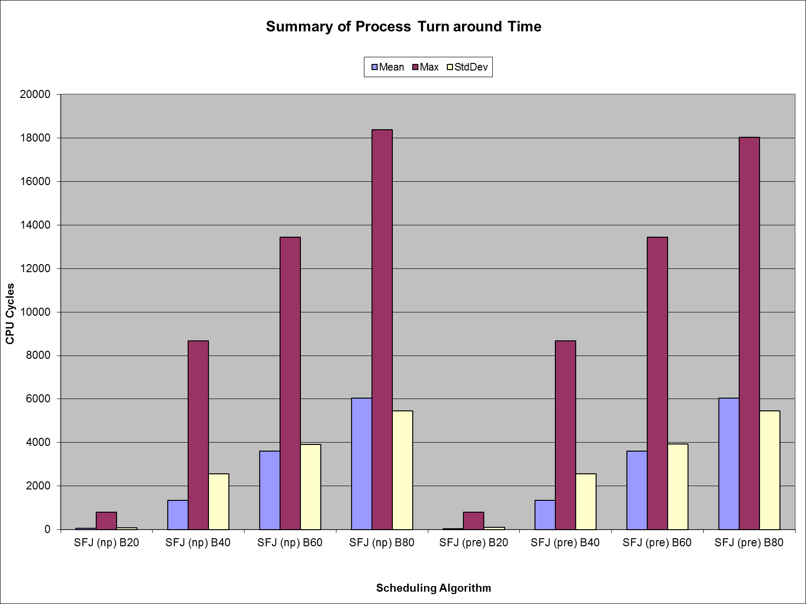

Jonathan Masukawa (33128396) Yan Zhao (31018809) Group #32

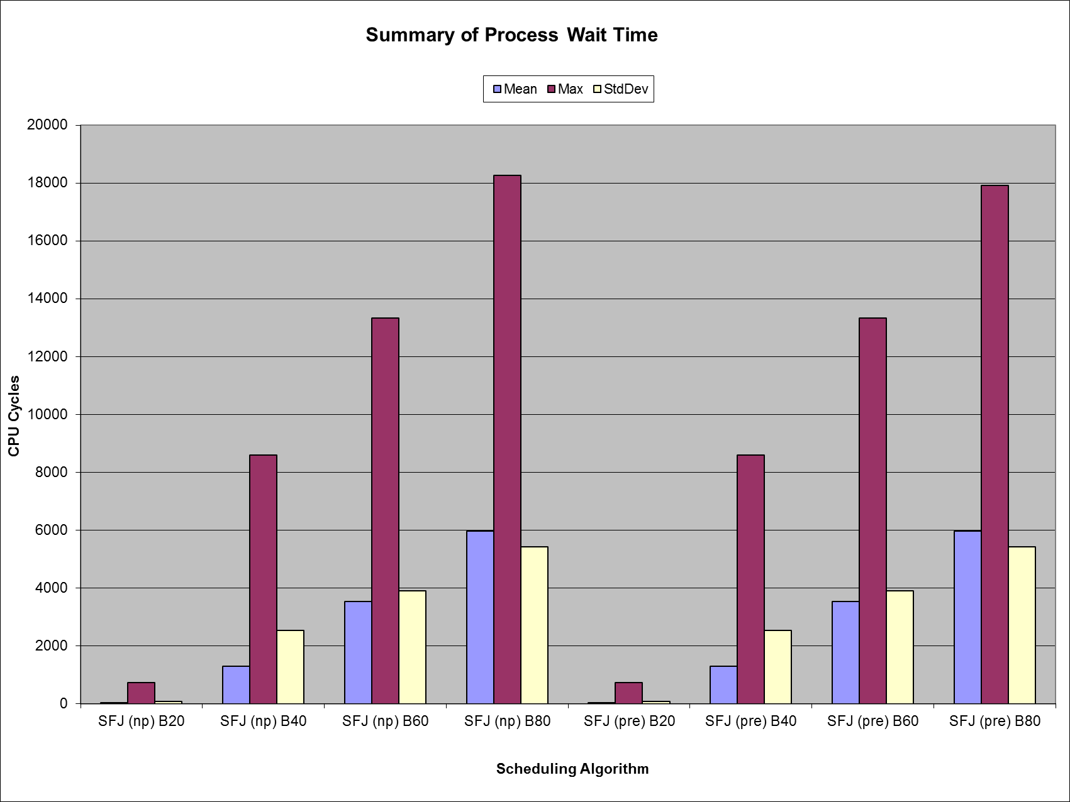

Jonathan Masukawa (33128396) Yan Zhao (31018809) Group #32

